FADM Assignment
GROUP - 3
HUL

Group Members
Roll Number | Name
P2511077 | Yashika Dhawan
P2511056 | Raunak Singh
P2511035 | Jiten Gupta
P2511033 | Jaya Agarwal
P2511009 | Ananya Negi
P2511018 | Ayush Dixit
P2511069 | Siddhi Kumari

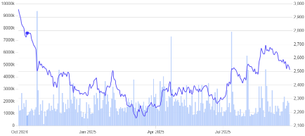

Section I — Introduction to HUL
About the Company
Source: www.screener.com
Hindustan Unilever Limited (HUL) is one of the top fast-moving consumer goods (FMCG) companies in India which operates in different categories of Home Care, Beauty & Personal Care, and Foods & Refreshment. HUL has a long heritage that goes back for decades and has many brands that meet the everyday needs of millions of consumers. The company operates high quality manufacturing plants throughout the country and has an extensive distribution network so that its products are available anywhere. HUL has a primary focus on India, but continues to grow through innovation, sustainability to consumers, and other approaches consistent with being an FMCG leader.
Stock Market data as 26 September, 2025

Market Cap - ₹ 5,90, 170 Cr.
CMP - ₹ 2,512
High/Low - ₹ 2,998/2,136
Stock Trends (Sept. 2024 – Sept. 2025)

Deliverable: Group written assignment - Analysis (listed company) using ratios for investment decision

Why We Chose Hindustan Unilever Limited (HUL)

Everyday Presence
When we began thinking about which company to analyze for this project, our group wanted to choose one that is not just big on paper but also deeply connected to our everyday lives. That is why we selected Hindustan Unilever Limited (HUL). Almost every Indian household has a piece of HUL in it, whether we notice it or not.
In the bathroom, you would almost always find brands like Dove, Lux, or Surf Excel. In the kitchen, there would be Kissan ketchup or Brooke Bond tea. On the dressing table, Lakmé, Pond’s, or Vaseline might be placed neatly. And opening the fridge, there is a good chance of finding a Kwality Wall’s ice cream. HUL has quietly woven itself into the fabric of our daily routines. This simple observation itself became one of our strongest reasons to pick HUL for our project.

Why Not Others?
While shortlisting companies, we did consider other FMCG giants like ITC, Nestlé, and P&G. Each of them has its strengths — ITC with its cigarettes and foods business, Nestlé with Maggi and dairy, P&G with personal care. But we realized that none of them had quite the same universal presence across so many categories of Indian households as HUL does. With HUL, it wasn’t just about studying a company; it was about studying a companion of everyday life.

A Legacy of 90+ Years
Beyond its household presence, there are deeper reasons why we admire this company. First, HUL has been operating in India for more than 90 years. Very few companies have been able to adapt to the changing tastes, generations, and economic conditions of India the way HUL has. From the pre-independence era to today’s digital age, HUL has not only survived but also remained the clear market leader in fast-moving consumer goods. For us, studying this means learning how businesses can remain relevant across time.

Diverse Portfolio
Second, we were drawn to HUL because of the variety and scale of its operations. With more than 50 brands across personal care, food, and home care, HUL does not depend on one single product line. Instead, it has a balanced presence across categories that are part of daily consumption. This allows us to see how different product segments contribute to the larger financial picture of the company.

Innovation and Adaptability
Third, we were interested in HUL’s ability to innovate and change with consumer needs. Over the years, it has launched premium products, responded to sustainability concerns, and even reshaped some of its oldest brands to fit modern times. For example, campaigns like “Daag Ache Hain” or the rebranding of “Fair & Lovely” show that HUL is not afraid to evolve with society. We felt this would give us a chance to study how strategic decisions impact financial performance.

A Personal Connect
Lastly, as students, there is also a personal element. When we realized that almost everything from our hostel shelves to our homes carried an HUL brand, it felt natural to analyze a company that we personally interact with every single day. It is not just numbers on a balance sheet for us; it is a company we see, use, and experience in our own lives.

Conclusion
For all these reasons — its presence in Indian households, its long history, its diverse portfolio, and its ability to adapt — we chose HUL. In the next sections, we will look at the company’s financial performance, analyze its strengths and weaknesses through ratios, and finally form an investment view on whether HUL continues to be as strong on paper as it is in our daily lives.

Section II — Analysis & Interpretation

Vertical Analysis
Income Statement:
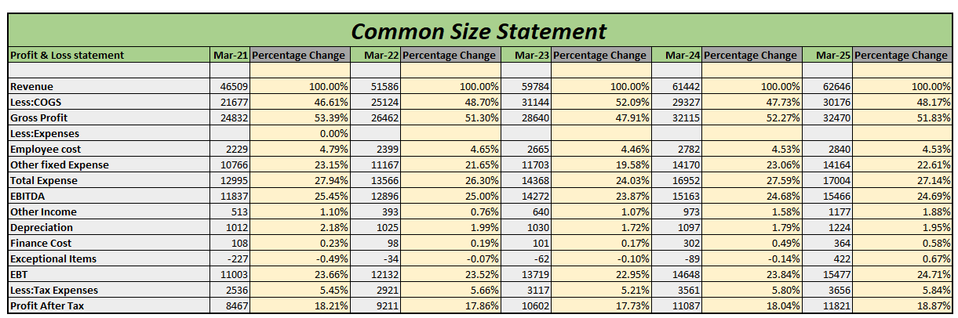
Figure 2 Income Statement Vertical Analysis
Inference:
- Revenue Growth: Steady increase each year, reaching ₹62,646 in Mar-25.
- COGS Trend: Fluctuates between 46–52% of revenue; peaks in Mar-23, reducing gross profit margin that year.
- Gross Profit: Consistently strong, ~48–53% of revenue; highest in Mar-24 (52.27%).
- Expenses:
  - Employee cost stable at ~4.5% of revenue.
  - Other fixed expenses reduced proportionally from 23.15% (Mar-21) to ~22% (Mar-25), showing cost efficiency.
- EBITDA: Maintained healthy levels (23–25% of revenue), slight dip in Mar-23.
- Depreciation: Relatively low and stable at ~1.7–2%.
- Finance Cost: Negligible (<1%).
- Profitability:
  - EBT consistently ~23–24%.
  - PAT margin stable between 17–18.8%, showing resilience.
Overall Inference: The company maintains stable margins with efficient cost management, negligible debt cost, and consistent profitability. Strong gross profit and PAT margins reflect operational efficiency and sustainability.

Balance Sheet:
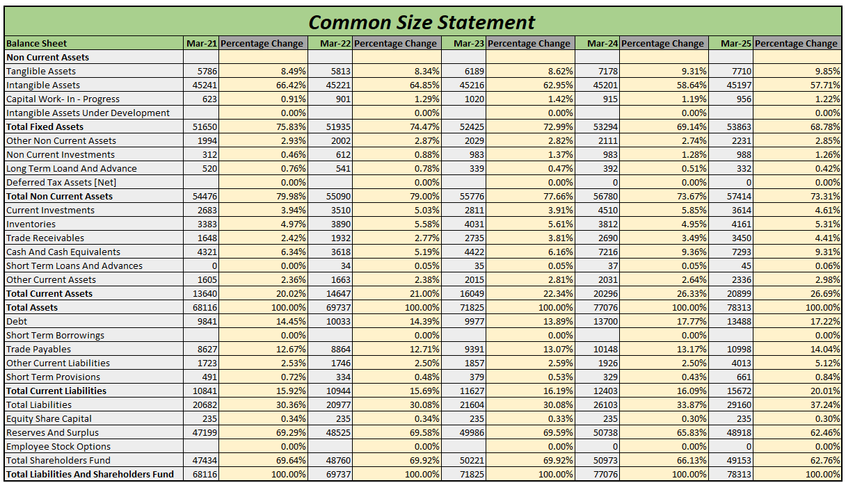
Figure 3 Balance Sheet Vertical Analysis
Inference:
- Asset Structure:
  - Non-current assets dominate (~73–80% of total), mainly intangible assets (falling from 66% in Mar-21 to ~57% in Mar-25).
  - Tangible assets steadily rising (from 8.5% to ~9.9%), showing gradual strengthening of physical base.
  - Current assets increased from 20% to ~27% of total, driven by higher cash & receivables, improving liquidity.
- Liabilities:
  - Debt stable in % terms (14–17%), manageable leverage.
  - Current liabilities rose from ~15.9% to 20%, led by trade payables, indicating higher reliance on short-term credit.
- Equity & Reserves:
  - Shareholders’ fund remains strong (~65–70% of total assets), though reserves’ share declined slightly (69% → 62%), suggesting increased liability dependence.
Overall Inference: The company is asset-heavy with strong intangibles but gradually shifting towards higher tangible and current assets. Equity base is robust, but rising current liabilities signal greater short-term obligations. Liquidity is improving, though liability management is crucial to maintain balance.

Horizontal Analysis

Income Statement

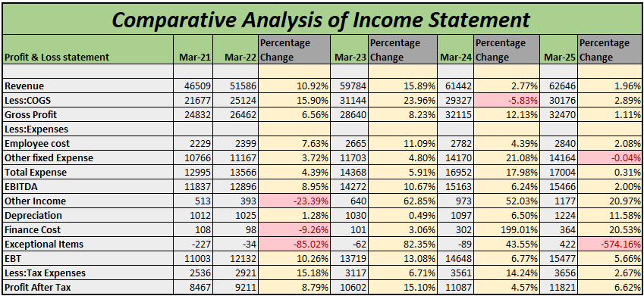
Figure 1 Income Statement Horizontal Analysis

Inference:
- Revenue Growth: Revenue grew consistently from Mar-21 to Mar-25, though growth slowed sharply after Mar-23 (from double digits earlier to just ~2 % in Mar-25).
- Cost Trend: COGS increased overall but showed a decline in Mar-24, improving gross margins temporarily.
- Profitability: Gross profit and EBITDA rose steadily, with the strongest jumps between Mar-22 and Mar-24. Growth moderated in Mar-25.
- Expenses: Employee and fixed expenses rose moderately; exceptional items fluctuated sharply, notably improving in Mar-24.
- Net Profit: Profit After Tax followed revenue and margin trends — strong double-digit growth till Mar-24, then slowing to ~6.6 % in Mar-25.
- Finance & Depreciation: Finance costs spiked in Mar-24–25, and depreciation increased steadily.
Overall: The company experienced strong post-Mar-21 growth with improving profitability through Mar-24, but momentum slowed in Mar-25, signalling possible stabilization or early signs of growth plateau.

Balance Sheet:

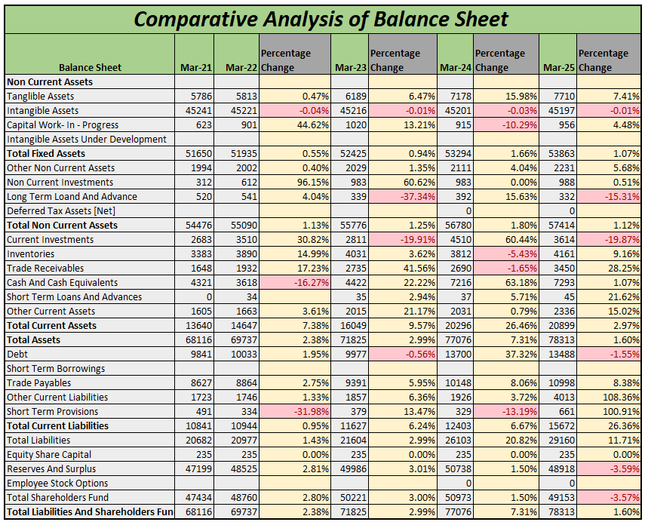
Figure 2 Balance Sheet Horizontal Analysis

Inference:
- Asset Growth: Total assets increased steadily each year, mainly driven by growth in non-current assets, particularly tangible assets and capital work-in-progress. Current assets grew faster from Mar-23 onward, led by cash & receivables.
- Investment & Liquidity: Strong growth in cash and current investments was seen in Mar-24–25, improving liquidity. Trade receivables rose sharply in Mar-25, indicating higher credit sales.
- Liabilities: Total liabilities grew moderately; short-term borrowings spiked in Mar-25, suggesting higher working capital needs. Trade payables also rose consistently.
- Equity Base: Shareholders’ funds increased steadily due to retained earnings, though a dip in reserves is visible in Mar-25, likely due to dividend payouts or adjustments.
Overall: The company maintained a balanced expansion in fixed and current assets, supported mainly by equity growth, while debt levels remained moderate with slight recent increases in short-term borrowings.

Graphical Representation

Figure 1 Sales Trends
Figure 2 EBITDA Trends

Figure 3 Net Profit Trends

Figure 4 Total Assets

Ratio Analysis

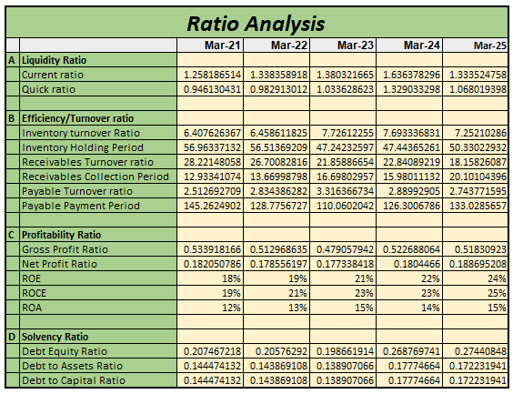
Figure 1 Ratio Analysis
A. Liquidity
- Current & Quick Ratios improved till Mar-24, showing stronger short-term liquidity, but slightly dipped in Mar-25.
- Liquidity remains comfortably above 1, indicating good short-term solvency.

B. Efficiency / Turnover
- Inventory turnover rose from 6.4 to ~7.2, implying better stock movement.
- Receivables collection period increased (13 → 20 days), indicating slower collections over time.
- Payable payment period fell initially, then rose again by Mar-25, suggesting slightly delayed payments to creditors.

C. Profitability
- Gross & Net profit ratios are stable but show a slight dip around Mar-23, then recover mildly.
- ROE, ROCE, ROA improved consistently, reaching 25% ROCE and 15% ROA by Mar-25 → profitability strengthened overall.

D. Solvency
- Debt ratios increased moderately from Mar-23 onwards, showing greater leverage, but still remain at healthy, low levels (<0.3).
Competitor Analysis

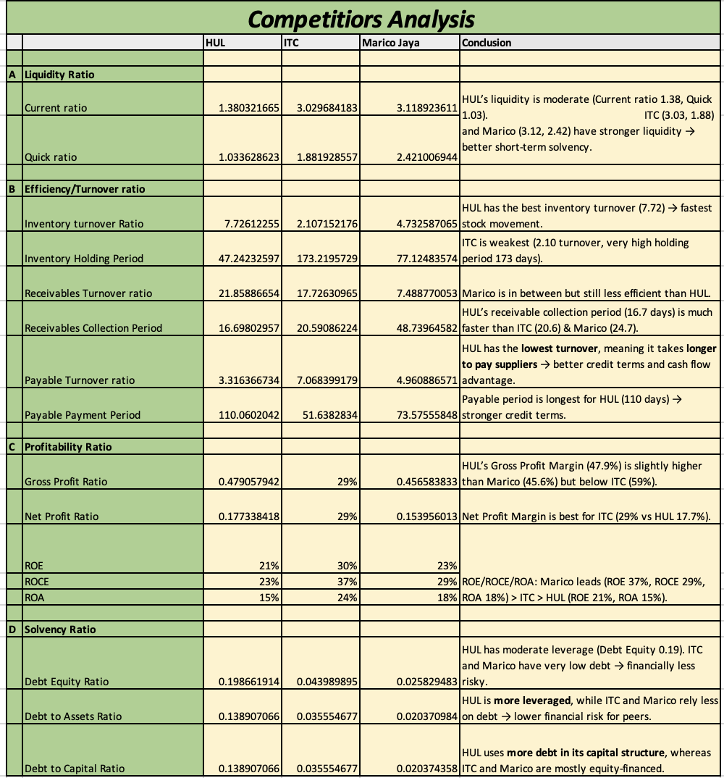
Figure 1 Competitors Analysis

Section III — Conclusion & Investment Recommendation

Appendices & Working Notes

Based on the uploaded ratio analysis and corroborated by the latest news, annual reports, and investment research sources, HUL remains a fundamentally strong company with excellent operational metrics and strategic adaptability. However, investors should note emerging short-term challenges and macroeconomic headwinds before making a decision.

Key Findings from Ratio Analysis
- Liquidity: HUL maintains moderate liquidity (Current Ratio: 1.38, Quick Ratio: 1.03), which aligns with best FMCG practices, balancing efficiency with safety.
- Efficiency: It leads in inventory and receivables management among peers—Inventory Holding Period (47 days), Receivables Collection Period (17 days)—resulting in faster cash flow and higher operational agility.
- Profitability: Margins remain strong but are below ITC (Net Profit Margin: 17.7%, ROE: 21%). This reflects healthy product mix but also the impact of inflationary challenges.
- Solvency: HUL employs more debt in its capital structure than ITC and Marico, but leverage is still moderate by industry norms (Debt Equity Ratio: 0.19).
Insights from Latest News and Reports
- Revenue & Profit Growth: HUL reported FY25 revenue of ₹60,680 crore and PAT of ₹10,644 crore, with net profit up 5% YoY and margin improvement to 17.5%.
- Portfolio Strength: 19 brands cross ₹1,000 crore annual turnover, with balanced revenue streams from Home Care, Beauty, Personal Care, and Foods.
- Digital Transformation: Accelerated digitization, premiumization, and use of AI are now central to HUL's strategy, with 1.4 million retailers onboarded digitally and three "Lighthouse" industry 4.0 plants.
- Sustainability: Over 97% of energy use is from renewables, and sourcing is 96% deforestation-free, underscoring sector leadership in ESG.
- Recent Challenges: In September 2025, HUL flagged short-term pressure from the GST rejig, causing supply chain and sales disruptions. The company expects near-flat growth for the quarter but sees this as a transitory issue, with recovery likely from November onwards as GST benefits stimulate demand.
Market Sentiment and Valuation
- Stock Performance: The stock recently held steady amidst market volatility, with analysts reiterating 'Hold' ratings as margins face short-term input cost pressure but medium-term fundamentals remain robust.
- Peer Comparison: Remains the operational gold standard in Indian FMCG, favored for defensive qualities, brand strength, and execution.
- Leadership: New leadership under Priya Nair is reorganizing the company to drive faster decision-making and growth.
Investment Conclusion
For Investment:
- HUL’s broad and strongly entrenched portfolio ensures demand resilience even in tough markets.
- Its industry-leading efficiency, digital adoption, and sustainability agenda are likely to drive long-term value.
- While recent GST/commodity price disruptions present short-term headwinds, these are transitory—not structural—and management’s response has been proactive.
- Solid cash flows, high returns, and premium market status support a continued investment case for stability and steady growth.
Risks/Watch Areas:
- Margin pressure due to input cost volatility and pricing constraints.
- High valuation multiples compared to some peers; market already prices in much of the sector leadership.
- Increasing use of leverage, while moderate, should be monitored for any signs of overextension.
Final view: HUL remains a high-quality, long-term holding for conservative and growth-focused portfolios alike. Short-term challenges exist, but its operational muscle, adaptability, and brand legacy make it a prime investment candidate for investors seeking stability, innovation, and sector leadership.

